An alternative to traditional aquas pretreatment of plastic
A process cost case study
Abstract
The conversion from traditional aquas pretreatment of injection molded parts at a 100-year-old manufacturer to a novel process utilizing vacuum technology has made a significant impact in process costs and quality.

Marshall Leininger
Senior Coatings Development Engineer
mleininger@vergason.com
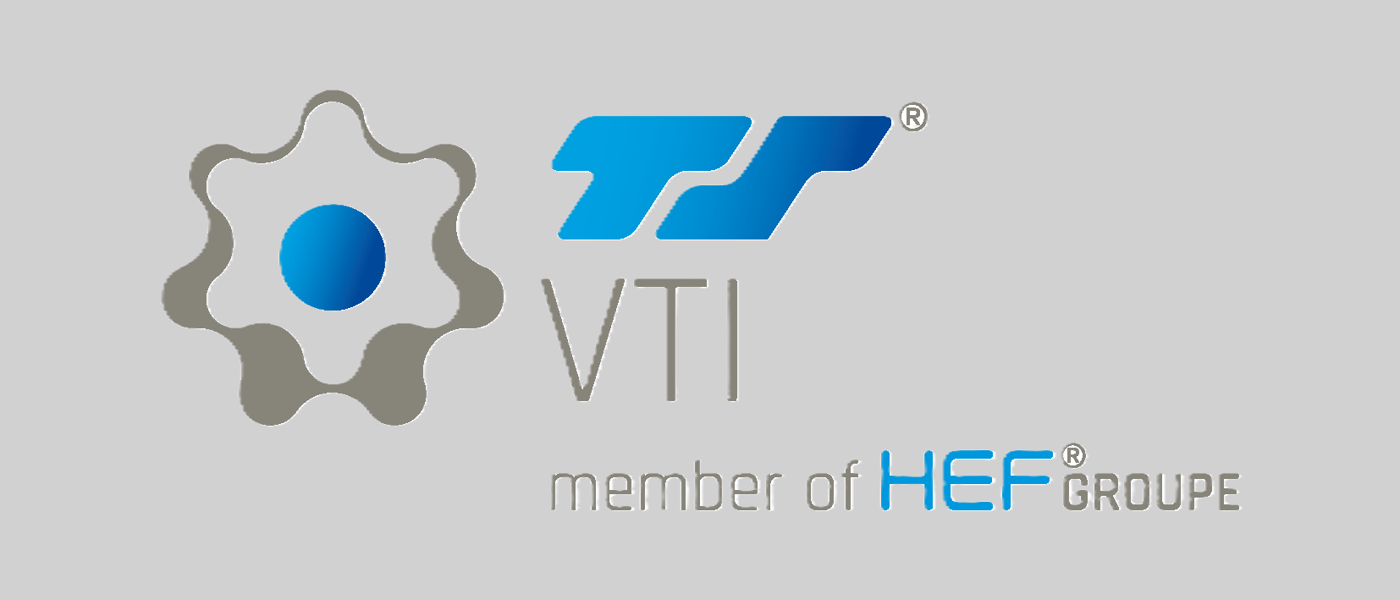
Background
The use of plastic materials in the manufacturing of products has expanded greatly across many industries over the past several years. With the rise of plastic uses and the development of specialty polymers the process of preparing the surface for decoration or painting has become increasingly complex. Painting or coating the surface is done to enhance appearance, to produce a color match with other parts, improve the stability and durability of the part, or to produce a special effect. To ensure that the painted or coated part meets performance requirements of the manufacturer and end user, the plastic parts must undergo some type of surface treatment prior to coating to remove surface contaminates such as dirt, release agents, grease and oils, and other materials that interfere with the final coating’s adhesion and required performance.
Plastic surface cleaning and treatment prior to coating can range from simple mechanical methods such as wiping and sanding to more involved methods such as chemical cleaning and plasma etching.
A long established and predominant method of chemical surface treatment is the use of water-born spray or dip systems made up of multiple stages of chemicals in water baths followed by with clean water rinses. These systems are often a large power wash system with sequential tanks with an overhead conveyor system with the parts mounted on racks that pass through the various stages of the process after which the conveyor runs through an air blow off followed by a convection oven to thoroughly dry the parts before painting.
Such a system was in place at Vergason Technology (VTI) customer Dixline Corporation. This system cleaned and prepared approximately 600 injection molded plastic parts per hour for paint application. The final spray stage before drying was a conductive adhesion promoter to aid in adhesion of a final decorative paint layer and also provide a conductive surface for the electrostatic painting process of that paint layer.
This pretreatment process had been a fixture in Dixline’s manufacturing processes for over 20 years and had proved to be a costly bottleneck. Dixline asked VTI if it knew of, or had, a possible alternative to this process.

Solution
Dixline has used a VTI Press Side 38 (PS38) PVD system for applying decorative metal coatings to a variety of their products for several years. The PS38 PVD system is a versatile magnetron sputtering machine with capabilities beyond decorative metallization, including CVD or Chemical Vapor Deposition processes. VTI had previously aided Dixline with programing the PS38 system to metalize standard powder coatings by including a CVD step in their deposition process.
The new process has three basic steps, a Plasma Etch to clean the substrate surface, a CVD step acting as a conversion process of the substrate surface to promote adhesion of paints and coatings, and a final PVD flash of metal that provides conductivity of the part for electrostatic painting as well as enhanced durability of the finished part. The process was developed at the Van Etten, New York facility on an in-house PS38 system with production parts and tooling before being introduced to Dixline’s daily production. This PE/CVD/PVD “precursor” to the painting process has proven out to Dixline with significant cost and quality benefits.

Comparing the Process
The original Dixline pretreatement process for plastic parts consisted of nine steps, the first six steps being performed in a wash system with presurized chemical and water rinse stages, followed by an air blow off, spray application of a water-borne adhesion promoter followed by a gas convection dry off and cure stage.

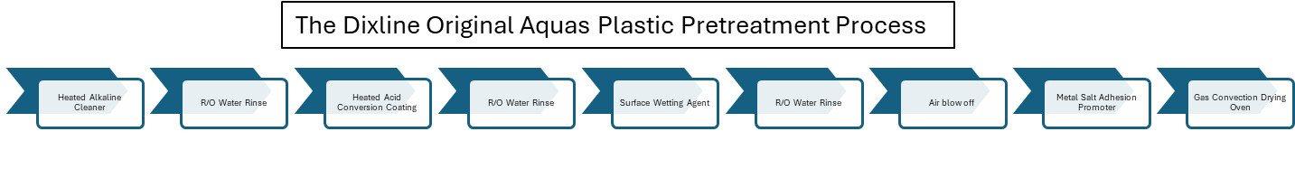
This process required over three hours to accomplish the required chemical impingement times, proper rinsing, and adhesion promoter drying and cure.

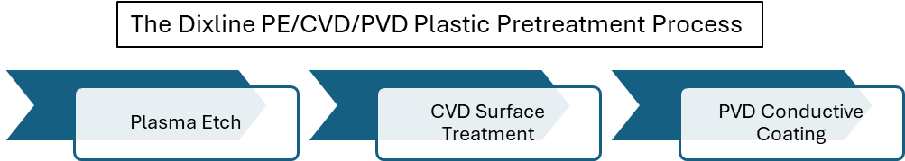
While the Precursor process is batch and the aquas pretreatment was continuous, each batch of parts through the PVD system is less than 4 minutes on a two-door loading system. Time between batches is an average of 5 seconds.
Comparing the Cost

Notes for Dixline Aquas Pretreatment System operations cost.
- R/O Water rinse stages are overflowed during operation at a constant rate of approximately 2 gallons per minute.
- Natural gas consumption is figured at an average mid-flame fire rate.
- Chemical use is calculated by shift stage recharge rates.

Cost differential of processes
Environmental
Quality affect
Beyond the significant cost savings, Dixline has realized an equally significant reduction in the cost of poor quality. Dixline could experience a 34%-part rejection rate attributed to the adhesion promotor prior to painting due to its narrow and difficult application parameters. After conversion to the PE/CVD/PVD process, rejections are stable under 3% through the entire precursor and paint processes. With the given throughput of 4800 parts per shift the conversion has saved over 1600 parts per shift going from a barely stable process to a very stable process.
Each of the aquas pretreatment chemical stages requires constant monitoring to maintain proper chemical balance. A trained and qualified technician must perform regular bath characteristics checks and titrations to maintain that balance. Any imbalance of the cleaning and conversion stages will negatively affect the tight application window of the adhesion promoter.
The entire PE/CVD/PVD process is accomplished in a single chamber rather than multiple stages and is tightly controlled by a PLC. The PLC also monitors every aspect of the process without human intervention. Simple cleaning routines ensure continuous quality.
Summary
The advantages of the /CVD/PVD conversion for Dixline has proven to be a dramatic improvement in time, process costs, and quality. The aquas pretreatment system has since been physically taken out of the process line with re-routing of the conveyor line and is slated for removal. The space recovered from the system removal will garner Dixline over 1000 square feet of additional manufacturing space, rather than build an addition to the plant that is already tight for space. The VTI PS38 has a footprint of just 200 square feet. With comparative costs of between 1.5 to 2 million dollars for an aquas system like the one at Dixline and $750,000 to $900,000 for a vacuum system shows that more process can be accomplished with better quality for less cost in less space. Since the inclusion of the precursor process, Dixline has added an additional VTI system.

Acknowledgement
VTI is grateful to the management and staff of Dixline Corporation for their openness and transparency in providing process data for this case study.

